Tri-Agency Guide on Financial Administration Course
Activity Booklet
Last updated: February 2020

Table of Contents
Purpose 3
Activity 1: From your Own Experience (30 min) 4
Activity 1 – Part 1: Identifying Scenarios of Uses of Grant Funds (10 min) 5
Activity 1-Part 2: Building Justifications for Scenarios of Appropriate Uses of Grant Funds (20 min) 7
Trainer notes: 10
Activity 2: Breach of Principle/Directive (40 min) 11
Activity 2—Part 1: Identifying Breach of Principles/Directives (15 min) 12
Activity 2-Part 2: Building a Justification for an Appropriate Use of Grant Funds (25 min) 13
Trainer notes: 21
Activity 3: Case Study (60 min) 22
Activity 3 – Part 1: First Assessment (20 min) 23
Activity 3—Part 2: Building Reverse Justification (20 min) 24
Activity 3—Part 3: Presentation (20 min) 25
Trainer notes 26
Appendix A: Bank of Scenarios 27
Directive 1: Employment and Compensation 27
Directive 2: Goods and Services Expenditures 32
Directive 3: Travel and Travel-Related Subsistence Expenditures 36
Directive 4: Hospitality Expenditures 39
Appendix B: Activity Printouts 45

TAGFA Course Activity Booklet

Purpose
The purpose of this Activity Booklet is to assist designated trainers at administering institutions with the preparation and delivery of up to three scenario-based “Brains-On” activities as part of the Tri-Agency Guide on Financial Administration (TAGFA) course.
The booklet contains the following details for each activity:
- Activity description;
- Learning objectives;
- Total suggested duration;
- Activity format;
- Delivery instructions;
- Trainer notes.

Trainers can pick one or more activities, and may choose to adapt their delivery based on their specific audience (e.g. size and general level of knowledge/familiarity with the new principles-based guide).
Appendix A contains a collection of scenarios, categorized by directive, which may be referenced and used by the trainer to build activities 2 and 3. While robust, trainers may wish to add scenarios to the current list or modify existing ones to respond to known interests and/or concerns from participants. Trainers may also request scenarios of interest from participants, to be used in or highlighted during the delivery of activities as appropriate.
Trainers are kindly invited to send any new scenarios used and/or general feedback on the TAGFA course to the three Agencies at Support-Soutien@cihr-irsc.gc.ca, in an effort to continuously improve the quality of this training package for all Canadian administering institutions.

Activity 1: From your Own Experience (30 min)

Part 1 Part 2
Building Justification for Use of Grant Funds
(Small or large group activity)

Identifying Scenarios of Use of Grant Funds
(Individual activity)
0 min 10 min 30 min
Description:
- In this 2-part activity, participants will draw from their own experiences in the area of financial administration to identify scenarios that illustrate an appropriate and inappropriate use of grant funds.
- For each scenario identified as an inappropriate use of grant funds, they will determine which TAGFA principle and/or directive was breached.
- In small groups, participants will select one scenario that illustrated an inappropriate use of grant funds and determine how it could be modified to represent an appropriate use of grant funds.
Learning objectives:
- To interpret and apply their knowledge of TAGFA principles and directives to real-life scenarios;
- To build justifications for an appropriate use of grant funds.
Total suggested duration: 30 minutes

Overview of Activity 1: From Your Own Experience
- Using the slide below, provide an overview of Activity 1.
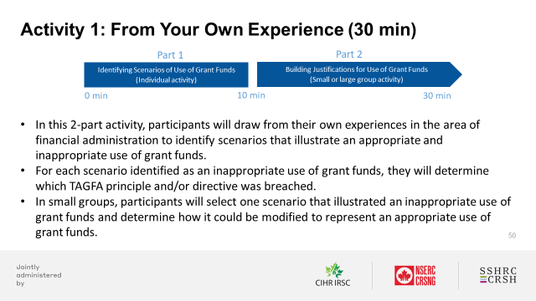

Activity 1 – Part 1: Identifying Scenarios of Uses of Grant Funds (10 min)

Getting started:
- To be completed individually.
- Use relevant slides (featured below) from the “Part 5: “Brains-On” Activities” section of the TAGFA Course PowerPoint deck to support your delivery.
- Follow the step-by-step instructions outlined below for this activity.
- Refer to the Trainer notes for this activity, available in this Activity Booklet.

Delivery of Activity 1 – Part 1: Identifying Scenarios of Uses of Grant Funds (10 min)
Identifying scenarios that illustrate appropriate and inappropriate uses of grant funds (5 min)
- Using the slide below and with the sticky notes provided, ask participants to identify scenarios that illustrate appropriate and inappropriate uses of grant funds.
- Remind everyone to use one sticky note per scenario.
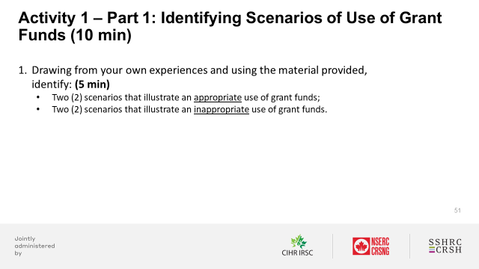

Categorizing scenarios to illustrate appropriate and inappropriate uses of grant funds (5 min)
- Using the slide below:
  - Draw attention to the TAGFA principles and directives;
  - Ask participants to categorize and illustrate appropriate and inappropriate uses of grant funds by posting their sticky notes under the relevant category or section.
- Observe, discuss and validate their choices/assessments.
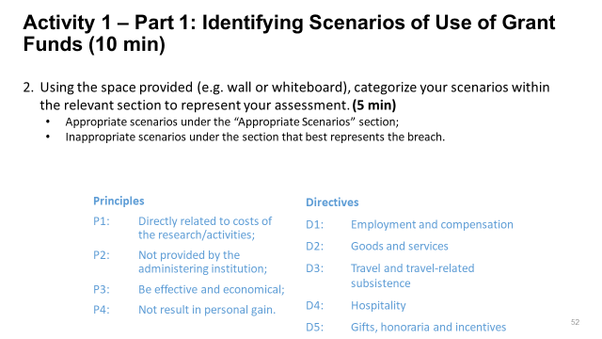

Activity 1-Part 2: Building Justifications for Scenarios of Appropriate Uses of Grant Funds (20 min)

Getting started:
- To be completed in small groups or one large group. Refer to the Delivery Guide to help you determine the most suitable approach.
- Use relevant slides (featured below) from the “Part 5: “Brains-On” Activities” section of the TAGFA Course PowerPoint deck to support your delivery.
- Follow the step-by-step instructions outlined below for this activity.
- Refer to the Trainer notes for this activity, available in this Activity Booklet.

Delivery of Activity 1 – Part 2: Building Justifications for Scenarios of Appropriate Uses of Grant Funds (20 min)

Small group format
Discussing a scenario that illustrates an inappropriate use of grant funds (5 min)
- Using the slide below, provide an overview of steps 1-3 of Activity 1 – Part 2.
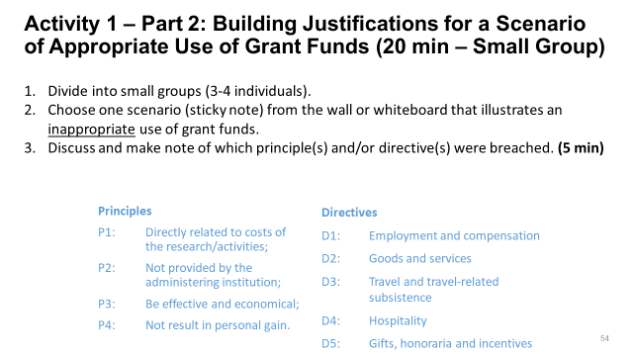

Turning a scenario that illustrates an inappropriate use of grant funds into an appropriate use of grant funds (5 min)
- Using the slide below, provide an overview of step 4 of Activity 1 – Part 2.
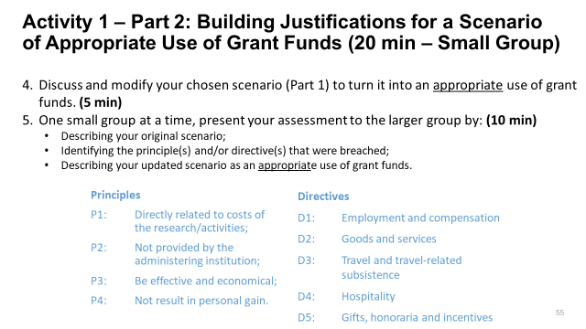
Presenting your assessment for an appropriate use of grant funds (10 min)
- Using the same slide (above), provide an overview of step 5 of Activity 1 – Part 2.
Large group format
Discussing a scenario that illustrates an inappropriate use of grant funds (5 min)
- Using the slide below, provide an overview of steps 1-2 of Activity 1 – Part 2.
- You may wish to post the scenario at the top of a PowerPoint slides and include the principles and directives at the bottom, or hand out copies of the scenario to each participant or table.
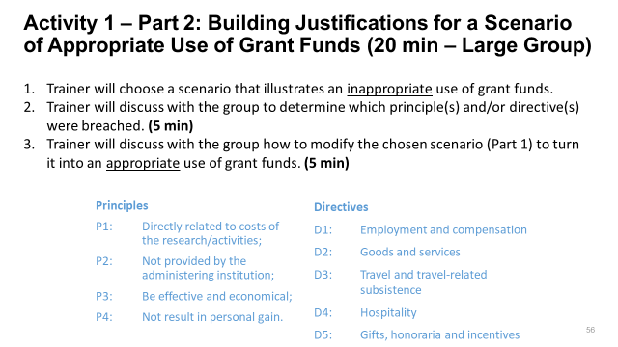
Turning a scenario that illustrates inappropriate use of grant funds into an appropriate use of grant funds (5 min)
- Using the same slide (above), provide an overview of step 3 of Activity 1 – Part 2.

Trainer notes:
- Build in sufficient time to prepare the room before the course is set to begin.
- Activity 1 focuses on the application of the Guide. As such, participants should be encouraged to assess their chosen scenario(s) against the TAGFA principles (4) and directives (5) only. They will be asked to assess scenarios against Program/Funding Opportunity literature, as well as their institution’s policies and directives, in other activities.
The ease with which participants will do so will depend on their knowledge of the principles and directives.
- Remind participants that the new Guide is less prescriptive than the former, and provides more flexibility to administering institutions in terms of what can reasonably be justified based on the principles and directives.
- Remind participants that in cases where scenarios lack the necessary detail to make a proper assessment, it should be assumed that the expenditure was made in good conscience and that common sense was applied. They should also be encouraged to document their experiences in their notes.
- In Activity 1 – Part 1:
  - Remind participants to use one sticky note per scenario.
  - One scenario could be suitable to more than one category. Ask participants to make a selection.
- In Activity 1 – Part 2:
  - One given scenario may breach more than one principle and/or directive. Participants should be asked to identify all principles and/or directives that apply.
  - A group can select any scenario from the wall to assess.
- Time permitting, you can ask each group to select more than one scenario.

Activity 2: Breach of Principle/Directive (40 min)

Part 1 Part 2
Building Justification for Use of Grant Funds
(Small or large group activity)

Identifying Breach of Principles/Directives
(Individual activity)
0 min 15 min 40 min
Description:
- In this 2-part activity, participants will identify which principle(s) and/or directive(s) have been breached for scenarios illustrating inappropriate uses of grant funds, as selected and posted by the trainer.
- In small groups, they will choose one scenario (e.g. from the wall or whiteboard) and assess the appropriateness of the use of grant funds, based on the suggested order of evaluation (i.e. the TAGFA principles and directives, the program/Funding Opportunity literature, and the institution’s policies and directives).
- Participants will then modify their chosen scenario to represent an appropriate use of grant funds.
Learning objectives:
- To effectively identify breaches to the TAGFA principles and/or directives;
- To build justifications for the appropriate use of grant funds.
Total suggested duration: 40 minutes

Overview of Activity 2: Breach of Principles/Directives
- Using the slide below, provide an overview of Activity 2.
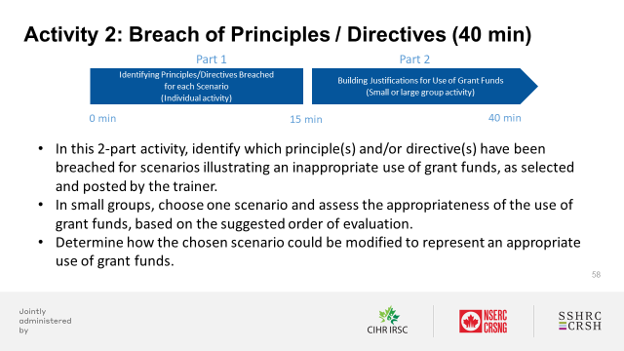

Activity 2—Part 1: Identifying Breach of Principles/Directives (15 min)

Getting started:
- To be completed individually.
- Use relevant slides (featured below) from the “Part 5: “Brains-On” Activities” section of the TAGFA Course PowerPoint deck to support your delivery.
- Follow the step-by-step instructions outlined below for this activity.
- Refer to the Trainer notes for this activity, available in this Activity Booklet.

Delivery of Activity 2 – Part 1: Identifying Principles/Directives Breached for Each Scenario (15 min)

Identifying principle(s) and/or directive(s) that have been breached for each scenario (5 min)
- Using the slide below, ask participants to identify which principle(s) and/or directive(s) have been breached for each scenario chosen by the trainer.
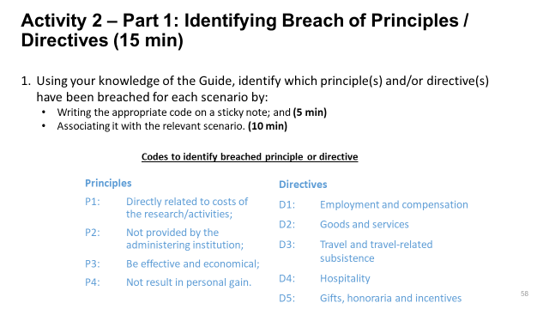
Discussing principles and/or directives (10 min)
- Observe the principles and/or directives identified by the participants.
- Challenge participants to discuss/question why their individual assessments (i.e. principles and/or directives breached) may be different or the same from one another’s.

Activity 2-Part 2: Building a Justification for an Appropriate Use of Grant Funds (25 min)

Getting started:
- To be completed in small groups or one large group. Refer to Delivery Guide to help you determine the most suitable approach.
- Use relevant slides (featured below) from the “Part 5: “Brains-On” Activities” section of the TAGFA Course PowerPoint deck to support your delivery.
- Follow the step-by-step instructions outlined below for this activity.
- Refer to the Trainer notes for this activity, available in this Activity Booklet.

Delivery of Activity 2 – Part 2: Building Justification for an Appropriate Use of Grant Funds
Small group format
Discussing a scenario that illustrates an inappropriate use of grant funds (5 min)
- Using the slide below, provide an overview of steps 1-3 of Activity 2 – Part 2.
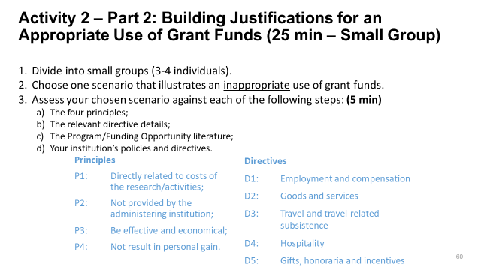
Demonstrating scenario assessments (10 min)
- Using the slide below read the scenario/example and ask participants to assess it against all four steps in their order of evaluation.
- Pause for discussion once a breach is identified.
- This scenario breaches Principle 1 “Directly related to the costs of the research/activities”.
- Since it was breached, look at the program and FO literature to see if the expenditure would be allowed under those.
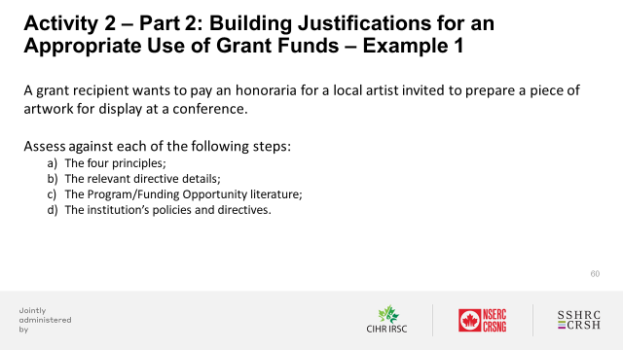
- Using the next slide (below), present a second scenario/example and ask participants to assess it against all four steps in their order of evaluation.
- Pause for discussion once a breach is identified.
- This scenario meets all principles and must therefore be assessed against the directives.
- This scenario meets all directives and must now be assessed against the program/Funding Opportunity literature.
- This scenario likely respects the program/Funding Opportunity literature therefore, it should be assessed against the institution’s policies and directives.
- Your institution may have a policy regarding the number of hours a PhD student can work on a research project however, there may be some restrictions.
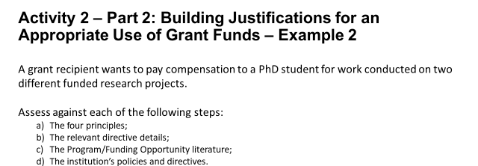
Discussing a scenario that illustrates an inappropriate use of grant funds (5 min)
- Using the slide below, run through steps 1-2 of Activity 2 – Part 2.
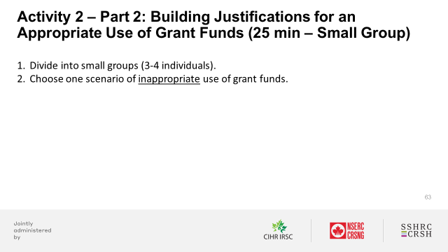
- Using the slide below, run through step 3 of Activity 2 – Part 2.
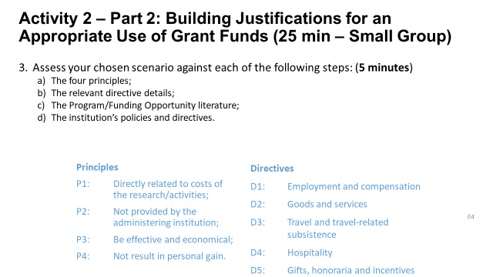

Turning a scenario that illustrated an inappropriate use of grant funds into an appropriate use of grant funds (10 min)
- Using the slide below, provide an overview of step 4 of Activity 2 – Part 2.
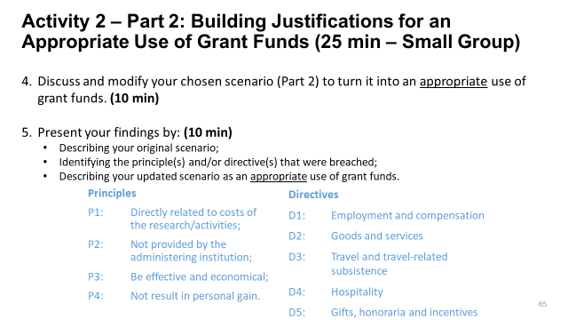
Presenting your assessment for an appropriate use of grant funds (10 min)
- Using the same slide (above), provide an overview of step 5 from Activity 2 – Part 2.
Large group format
Discussing a scenario that illustrates an inappropriate use of grant funds (5 min)
- Using the slide below, start the demonstration by highlighting that the scenario will be assessed together against the following four steps in their order of evaluation.
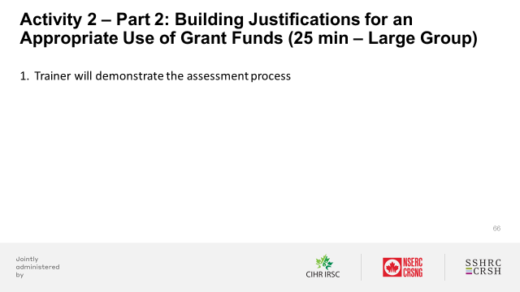
Demonstrating scenario assessments (10 min)
- Using the slide below, read the scenario/example and ask participants to assess it against all four steps in their order of evaluation.
- Pause for discussion once a breach is identified.
- This scenario breaches Principle 1 “Directly related to the costs of the research/activities”.
- Since it was breached, look at the program and FO literature to see if the expenditure would be allowed under those.
- Using the next slide (below), read the scenario/example and ask participants to assess it against all four steps in their order of evaluation.
- Pause for discussion once a breach is identified.
- This scenario meets all principles and must therefore be assessed against the directives.
- This scenario meets all directives and must now be assessed against the program/Funding Opportunity literature.
- This scenario likely respects the program/Funding Opportunity literature therefore, it should be assessed against the institution’s policies and directives.
- Your institution may have a policy regarding the number of hours a PhD student can work on a research project however, there may be some restrictions.
Discussing a scenario that illustrates an inappropriate use of grant funds (5 min)
- Using the slide below, initiate the group discussion.
- Select one scenario (e.g. wall or whiteboard) and read it to the group.
- Naming the principles one at the time, ask the group if they believe the principle in question is breached.
- Naming the directives one at the time, ask the group if they believe the directive in question is breached.
- Compare the results from this assessment with those identified in Part 1 of this activity.
- Ask the group to assess the scenario against examples of program/Funding Opportunity literature.
- Ask the group to assess the scenario against institution policies and directives that could be applied.
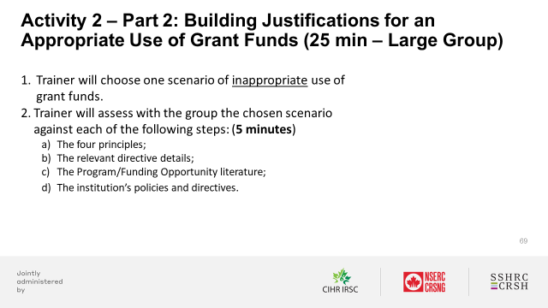
Turning a scenario that illustrated an inappropriate use of grant funds into an appropriate use of grant funds (5 min)
- Ask each group to identify the details that could be modified and/or added to the scenario to turn it into an appropriate use of grant funds.
- Ask the group to re-assess the scenario against the principles and directives, based on the added detail.
- Ask the group to assess the scenario against examples of program/Funding Opportunity literature.
- Ask the group to assess the scenario against institution policies and directives that could be applied.
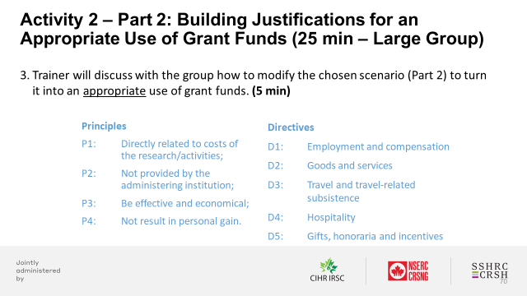

Trainer notes:
- Build in sufficient time to prepare the room before the course is set to begin.
- Select scenarios (see Appendix A) that are most meaningful or impactful for your audience. (Note: You may also select your own scenarios that represent inappropriate uses of grant funds).
- Participants should be encouraged to assess their chosen scenarios against the four steps in their order of evaluation:
  - The four principles;
  - The relevant directive details;
  - The program/Funding Opportunity literature;
  - The institution’s policies and directives.
The ease with which participants will do so will depend on their knowledge of the policies and directives.
- Remind participants of the importance of executing all steps from the order of evaluation before making a final determination.
- Remind participants that the new Guide is less prescriptive than the former , and provides more flexibility to administering institutions in terms of what can reasonably be justified based on the principles and directives stated.
- Remind participants that in cases where scenarios lack the necessary detail to make a proper assessment, it should be assumed that the expenditure was made in good conscience and that common sense was applied. They should also be encouraged to document their experiences in their notes.
- One given scenario may breach more than one principle and/or directive. Participants should be asked to identify all principles and/or directives that apply.
- Remind participants to use one sticky note per principle/directive.

Activity 3: Case Study (60 min)

Part 1 Part 2 Part 3
Presentation
(Small group activity)

Building Reverse Justification
(Small group activity)
First Assessment
(Small group activity)
0 min 20 min 40 min 60 min
Description:
- In this 3-part delivery activity, participants will choose a scenario (e.g. from the wall or whiteboard) and make an initial assessment (i.e. appropriate or inappropriate use of grant funds) based on the four steps and in their order of evaluation.
- Participants will then modify their chosen scenario to represent an appropriate or inappropriate use of grant funds (i.e. opposite of their initial assessment), and present their case study to the group.
Learning objectives:
- To interpret and apply the TAGFA principles and directives for a given scenario;
- To understand to the order of evaluation and the order of precedence of all applicable TAGFA principles and directives, as well program/Funding Opportunity literature and the institution’s policies and directive;
- To build justifications for the appropriate or inappropriate use of grant funds, using their knowledge of TAGFA principles and directives.
Total suggested duration: 60 minutes

Overview of Activity 3: Case Study
- Using the slide below, provide an overview of Activity 3.
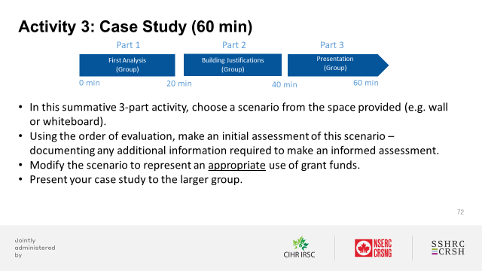

Activity 3 – Part 1: First Assessment (20 min)

Getting started:
- To be completed in small groups (suggested: 3-4 individuals).
- Use relevant slides (featured below) from the “Part 5: “Brains-On” Activities” section of the TAGFA Course PowerPoint deck to support your delivery.
- Follow the step-by-step instructions outlined below for this activity.
- Refer to the Trainer notes for this activity, available in this Activity Booklet.

Delivery of Activity 3 – Part 1: First Assessment (20 min)
Assessing the appropriateness or inappropriateness of use of grant funds scenario (20 min)
- Using the slide below, ask each group to choose one scenario from those posted (e.g. wall or whiteboard) and to assess it against the four criteria based on their order of evaluation.
- Ask each group to document the step-by-step details relative to their assessment using the material at their disposal (e.g. flipchart or a piece of paper).
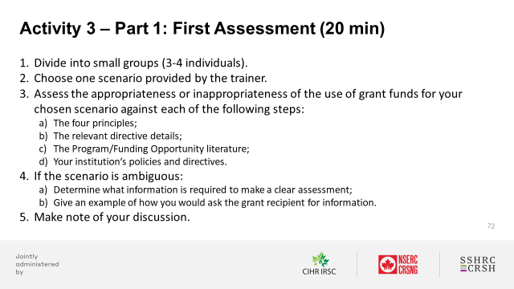

Activity 3—Part 2: Building Reverse Justification (20 min)

Getting Started:
- To be completed in small groups (suggested:3-4 individuals).
- Use relevant slides (featured below) from the “Part 5: “Brains-On” Activities” section of the TAGFA Course PowerPoint deck to support your delivery.
- Follow the step-by-step instructions outlined below for this activity.
- Refer to the Trainer notes for this activity, available in this Activity Booklet.

Delivery of Activity 3 – Part 2: Building Reverse Justification (20 min)
Turning a scenario into an appropriate or inappropriate use of grant funds (opposite of original assessment) (20 min)
- Using the slide below, provide an overview of steps 1-3 of Activity 3 – Part 2.
- Ask each group to modify their chosen scenario to represent an appropriate or inappropriate use of grant funds (i.e. opposite of their initial assessment).
- Ask each group to document the step-by-step details relative to their assessment using the material at their disposal (e.g. flipchart or a piece of paper).
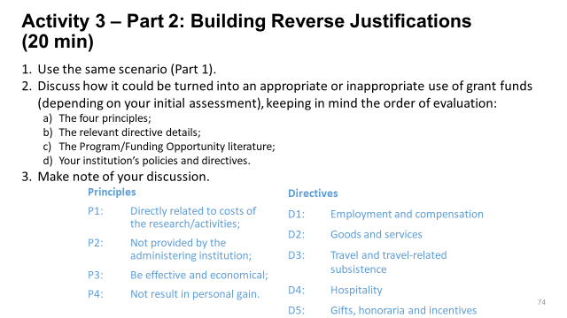

Activity 3—Part 3: Presentation (20 min)

Getting started:
- To be completed in small groups (suggested: 3-4 individuals).
- Use relevant slides (featured below) from the “Part 5: “Brains-On” Activities” section of the TAGFA Course PowerPoint deck to support your delivery.
- Follow the step-by-step instructions outlined below for this activity.
- Refer to the Trainer notes for this activity, available in this Activity Booklet.

Delivery of Activity 3 – Part 3: Presentation (20 min)
Presenting a case study (20 min)
- Using the slide below, provide an overview of step 1 of Activity 3 – Part 3.
- Open the floor for discussion.
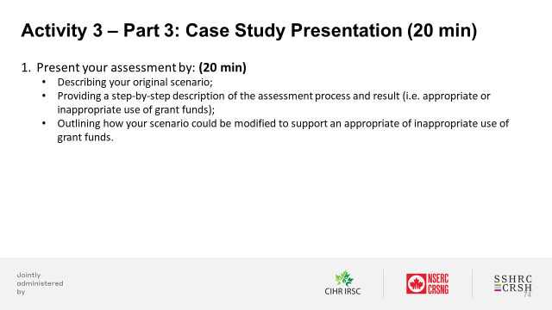

Trainer notes
- Select scenarios (see Appendix A) that are intentionally ambiguous in terms of their determination (i.e. appropriate or inappropriate use of grant funds) to stimulate discussion amongst participants regarding their assessments.. (Note: You may also select your own scenarios of ambiguous determination).
- Participants should be encouraged to assess their chosen scenarios against the four steps in their order of evaluation:
  - The four principles;
  - The relevant directive details;
  - The program/Funding Opportunity literature;
  - The institution’s policies and directives.
The ease with which participants will do so will depend on their knowledge of the policies and directives.
- Remind participants of the importance of executing all steps from the order of evaluation before making a final determination.
- Be attentive to the ways in which participants apply the principles and directives from the Guide. For example, you may want to make sure that they do not confuse program/Funding Opportunity literature with TAGFA directives. The scenario should be assessed against all four steps in their order of evaluation.
- Remind participants that the new Guide is less prescriptive than the former, and provides more flexibility to the institutions in terms or what can reasonably be justified based on the principles and directives stated.

Appendix A: Bank of Scenarios
The following scenarios are categorized by directive and should be used in the delivery of activities 2 and 3.
Important note: The assessment of appropriateness suggested for each scenario is based on the interpretation of the description provided, and assumptions are made when details are missing. This assessment could be reversed based on the inclusion of additional detail or information.

Directive 1: Employment and Compensation
ID | Description | Details and answers
1.1 | A grant recipient wants to hire a communications and logistics coordinator to do some project logistics work abroad and this person is an employee of a foreign organization partner on her grant. | Viewpoint: Principles  It should be an appropriate use of grant funds.  Viewpoint: TAGFA directives  In either case, the coordinator cannot be paid directly from the grant. While this is unlikely to be an appropriate use of grant funds, you must nonetheless consider the nature of the agreement with the partner. This will dictate the appropriateness of the expenditure.  If the coordinator is paid by the other organization and the service is not meant to be free according to the partnership agreement, the organization can be reimbursed for the work done by the coordinator.  Viewpoint: Program/Funding Opportunity literature  Anything that specifies what is expected from the partner organization.  Viewpoint: Institution’s policies and directives  The employment and compensation of individuals to work on the funded research/activities must be in accordance with the administering institution’s relevant policies and processes.

1.2 | A grant recipient wants to compensate a Canadian visiting scholar for their contribution to his research project while they are conducting research as part of their studies. | Viewpoint: Principles  It should be an appropriate use of grant funds.  Viewpoint: TAGFA directives  An independent researcher cannot be compensated from grant funds. Furthermore, if the individual is expected to provide services free of charge, he cannot be compensated.  This is unlikely to be an appropriate use of grant funds.  Viewpoint: Program/Funding Opportunity literature  Since the Program/Funding Opportunity literature takes precedence over the Guide, you will want to confirm with these to see if they would allow such expenditure.  Viewpoint: Institution’s policies and directives  Do not need to evaluate against this criterion.
1.3 | A grant recipient wants to compensate a PhD student who is based out of a co-applicant’s lab. | Viewpoint: Principles  It should be an appropriate use of grant funds.  Viewpoint: TAGFA directives  It should be an appropriate use of grant funds.  Viewpoint: Program/Funding Opportunity literature  Though possible, it is unlikely that a program would restrict compensation for a student.  Viewpoint: Institution’s policies and directives  Institutions may have limitations on the number of hours a student is allowed to work.

1.4 | A grant recipient wants to bring and compensate an expert researcher working at the US non-profit Stockholm Environment Institute to work on her project for a 3-month period to conduct joint analysis and writing as part of the Open Research Area she is proposing. | Viewpoint: Principles  Depending on the salary of this expert researcher, additional justification may be required to meet the Principle “effective and economical”. Otherwise, it may meet all four principles.  Viewpoint: TAGFA directives  International researchers may be compensated from grant funds, provided this can be substantiated through a letter from their employer indicating that he/she is not being compensated for time spent working on the grant funded research/activities.  Viewpoint: Program/Funding Opportunity literature  It is unlikely that a program or FO would impose limitations in this case.  Viewpoint: Institution’s policies and directives  The employment and compensation of individuals to work on the funded research/activities must be in accordance with the administering institution’s relevant policies and processes.
1.5 | A grant recipient is paying some graduate students in the US who are not affiliated to any Canadian University. They are working on his funded research activities. | Viewpoint: Principles  The justification should establish the need in relation to the grant recipient’s funded research to meet the Principle “Directly related to costs of the research/ activities”.  Viewpoint: TAGFA directives  The new Guide is silent about the residency status of students. The grant recipient may hire a foreign student if required to meet specific research needs.  Viewpoint: Program/Funding Opportunity literature  It is unlikely that a program or FO would impose limitations in this case.  Viewpoint: Institution’s policies and directives  The employment and compensation of individuals to work on the funded research/activities must be in accordance with the administering institution’s relevant policies and processes.

1.6 | When research staff are hired as employees, they are offered extended health benefits as part of an overall compensation package as long as this is consistent across the institution. These employees may reject the benefits in favor of a higher salary. A grant recipient wants to pay her new research staff that extra salary from her grant. | Viewpoint: Principles  Additional justification may be required to meet the Principle “Effective and economical”. Otherwise, it may meet all four principles.  Viewpoint: TAGFA directives  If employment includes the provision of compensation benefits, the administering institution’s share of the costs of mandated compensation benefits is eligible for reimbursement from the grant funds.  The new guide provides the following definition of compensation benefits: “Employment based benefits that are mandated to be provided by legislation, (such as but not limited to CPP, EI, etc.), and/or are mandated to be provided by the administering institutions’ employment policies, collective agreements, etc. (such as but not limited to health, dental etc.)”.  Since the extended health benefit referred to in this scenario is not a mandated benefit, it would not be considered an appropriate use of grant funds. Therefore, the extra portion of the salary is unlikely to be an appropriate use of grant funds.  Viewpoint: Program/Funding Opportunity literature  Since the Program/Funding Opportunity literature takes precedence over the Guide, you will want to confirm with these to see if they would allow such expenditure.  Viewpoint: Institution’s policies and directives  Do not need to evaluate against this criterion.

1.7 | A grant recipient would like to compensate a principal investigator from another university who is not funded by Tri-Agency funds for work she is doing on the funded research activities. | Viewpoint: Principles  It should be an appropriate use of grant funds.  Viewpoint: TAGFA directives  According to the Guide, agency grant funds must not be used to pay compensation to grant recipients or individuals who conduct research independently as part of the terms and conditions of their employment, including but not limited to researchers in academia, hospitals or research institutes.  Furthermore, if the individual is expected to provide services free of charge, then he/she cannot be compensated.  This is unlikely to be an appropriate use of grant funds.  Viewpoint: Program/Funding Opportunity literature  Since the Program/Funding Opportunity literature takes precedence over the Guide, you will want to confirm with these to see if they would allow such expenditure.  Viewpoint: Institution’s policies and directives  Do not need to evaluate against this criterion.

Directive 2: Goods and Services Expenditures
ID | Description | Details and answers
2.1 | A grant recipient wants to claim his home internet expenses because he is working on his funded research activities from his home office. | Viewpoint: Principles  Justification may be required to make sure that the Principle “Not result in personal gain” is not breached. Once confirmed, it is likely to be considered an appropriate use of grant funds.  Viewpoint: TAGFA directives  It should be an appropriate use of grant funds.  Viewpoint: Program/Funding Opportunity literature  The terms and conditions of the funding opportunity should be consulted to determine whether there are any restrictions concerning the acquisition of goods and services.  Viewpoint: Institution’s policies and directives  The acquisition of goods and services for the funded research/activities must be undertaken in accordance with the administering institution’s relevant policies and processes.
2.2 | A grant recipient wants to claim the end-of-grant purchase for many books needed to prepare and write the research paper. | Viewpoint: Principles  It should be an appropriate use of grant funds.  Viewpoint: TAGFA directives  The timing of a purchase has no bearing on the expense’s eligibility therefore; it should be an appropriate use of funds.  Viewpoint: Program/Funding Opportunity literature  The terms and conditions of the funding opportunity should be consulted to determine whether there are any restrictions concerning the acquisition of goods and services.  Viewpoint: Institution’s policies and directives  The acquisition of goods and services for the funded research/activities must be undertaken in accordance with the administering institution’s relevant policies and processes.

2.3 | A grant recipient is using wristbands to measure heartrate as part of her project. She wants to claim these as support for research tools. | Viewpoint: Principles  It should be an appropriate use of grant funds.  Viewpoint: TAGFA directives  It should be an appropriate use of grant funds.  Viewpoint: Program/Funding Opportunity literature  SSHRC defines Research Tools as “vehicles that broadly facilitate research and related activities. Social science and humanities tools enable researchers to collect, organize, analyze, visualize, mobilize and store quantitative and qualitative data and creative outputs. Tools can be created as part of a research or related undertaking, or purchased off the shelf”.  Based on this definition, the wristband qualifies as a tool and would count towards the “Support for Research Tools” caps of $7,000  Viewpoint: Institution’s policies and directives  The acquisition of goods and services for the funded research/activities must be undertaken in accordance with the administering institution’s relevant policies and processes.
2.4 | A grant recipient would like to claim the purchase a research vehicle ($40-50K) with his grant funds. | Viewpoint: Principles  Justification may be required to confirm how the vehicle directly contributes to the research.  Justification may also be required to confirm that the cost of this vehicle is effective and economical.  If it does, then it should be an appropriate use of funds.  Viewpoint: TAGFA directives  It should be an appropriate use of funds.  Viewpoint: Program/Funding Opportunity literature  The terms and conditions of the funding opportunity should be consulted to determine whether there are any restrictions concerning the acquisition of goods and services.  Viewpoint: Institution’s policies and directives  The acquisition of goods and services for the funded research/activities must be undertaken in accordance with the administering institution’s relevant policies and processes.
2.5 | A grant recipient wants to claim the cost of an insurance deductible, which occurred when a student working on her project got into a car accident while conducting research activities. | Viewpoint: Principles  It should be an appropriate use of grant funds.  Viewpoint: TAGFA directives  It should be an appropriate use of grant funds.  Viewpoint: Program/Funding Opportunity literature  The terms and conditions of the funding opportunity should be consulted to determine whether there are any restrictions concerning the acquisition of goods and services.  Viewpoint: Institution’s policies and directives  The acquisition of goods and services for the funded research/activities must be undertaken in accordance with the administering institution’s relevant policies and processes.
2.6 | A grant recipient wants to claim the purchase of 10 copies of a book written by himself. The reason given by the recipient is that the expense falls under the dissemination category of his grant. | Viewpoint: Principles  Given that the royalties generated from this purchase are minimal, personal gain does not impact the outcome of research or activities subsidized by the funds. Therefore,  the expense should be considered an appropriate use of grant funds.  Viewpoint: TAGFA directives  It should be an appropriate use of grant funds.  Viewpoint: Program/Funding Opportunity literature  The terms and conditions of the funding opportunity should be consulted to determine whether there are any restrictions concerning the acquisition of goods and services.  Viewpoint: Institution’s policies and directives  The acquisition of goods and services for the funded research/activities must be undertaken in accordance with the administering institution’s relevant policies and processes.

2.7 | A grant recipient has a student working on one of her research grants. His role on this project is data analysis – which requires the use of a computer. The student’s personal computer broke, and the grant recipient wants to claim the cost to repair the laptop.  Note – the student is not located in the same city as the university and as such, is not able to access university’s computers for this work.  Is the location of the student truly a factor in this assessment? Would it still be eligible if the student was in the same city? Would it be more economical to purchase a new computer? | Viewpoint: Principles  It should be an appropriate use of grant funds.  Viewpoint: TAGFA directives  It should be an appropriate use of grant funds.  Viewpoint: Program/Funding Opportunity literature  The terms and conditions of the funding opportunity should be consulted to determine whether there are any restrictions concerning the acquisition of goods and services.  Viewpoint: Institution’s policies and directives  The acquisition of goods and services for the funded research/activities must be undertaken in accordance with the administering institution’s relevant policies and processes.

Directive 3: Travel and Travel-Related Subsistence Expenditures
ID | Description | Details and answers
3.1 | A grant recipient on sabbatical goes somewhere to do research and wants to claim his living expenses for the duration of the stay. He opted to live in luxury condominium in the downtown area of the city.  Does this assessment change if he has gone somewhere to collaborate in person with another researcher at an institution in the city he is in? | Viewpoint: TAGFA principles  This does not appear to be an effective and economical use of funds. Additional justifications would be required.  It is unlikely to be an appropriate use of grant funds.  Viewpoint: TAGFA directives  There is no need to evaluate against this criterion.  Viewpoint: Program/Funding Opportunity literature  Since the Program/Funding Opportunity literature takes precedence over the Guide, you will want to confirm with these to see if they would allow such expenditure.  Viewpoint: Institution’s policies and directives  There is no need to evaluate against this criterion.
3.2 | A grant recipient wants to claim the travel and subsistence costs for 5 participants in an intercultural research gathering planned at Six Nations? These individuals are named as research participants on the project. | Viewpoint: TAGFA principles  It should be an appropriate use of grant funds.  Viewpoint: TAGFA directives  It should be an appropriate use of grant funds.  Viewpoint: Program/Funding Opportunity literature  The terms and conditions of the funding opportunity should be consulted to determine whether there are any restrictions concerning the location of research and this type of expenditure.  Viewpoint: Institution’s policies and directives  All travel and travel-related subsistence expenditures (meals and accommodation) must be claimed in accordance with the administering institution’s relevant policies and processes.

3.3 | A grant recipient wants to claim the travel expenses to bring participants from a partner organization to attend research project meeting. | Viewpoint: TAGFA principles  It should be an appropriate use of grant funds.  Viewpoint: TAGFA directives  It should be an appropriate use of grant funds.  Viewpoint: Program/Funding Opportunity literature  The terms and conditions of the funding opportunity should be consulted to determine whether there are any restrictions concerning the location of research and this type of expenditure.  Viewpoint: Institution’s policies and directives  All travel and travel-related subsistence expenditures (meals and accommodation) must be claimed in accordance with the administering institution’s relevant policies and processes.
3.4 | A grant recipient wants to use her grant funds to pay the rent of a room/or some sort of shared accommodations while on sabbatical leave for six months, such as a house share or sublet. | Viewpoint: TAGFA principles  The purpose of the sabbatical should be clearly identified as research related activities. Furthermore, the researcher may need to prove that this type of accommodation is more economical.  Given these two requirements, it should be an appropriate use of grant funds.  Viewpoint: TAGFA directives  It should be an appropriate use of grant funds.  Viewpoint: Program/Funding Opportunity literature  The terms and conditions of the funding opportunity should be consulted to determine whether there are any restrictions concerning the location of research and this type of expenditure.  Viewpoint: Institution’s policies and directives  All travel and travel-related subsistence expenditures (meals and accommodation) must be claimed in accordance with the administering institution’s relevant policies and processes.

3.5 | A grant recipient submitted a travel claim against his grant for a trip to attend a student’s thesis defense. | Viewpoint: TAGFA principles  The thesis defense of students does not contribute directly to the funded research.  This is unlikely to be an appropriate use of grant funds.  Viewpoint: TAGFA directives  Do not need to evaluate against this criterion.  Viewpoint: Program/Funding Opportunity literature  Since the Program/Funding Opportunity literature takes precedence over the Guide, you will want to confirm with these to see if they would allow such expenditure.  Viewpoint: Institution’s policies and directives  Do not need to evaluate against this criterion.
3.6 | A grant recipient wants to claim the travel expenses related to a conference hosted on a cruise ship. She is both presenting and attending workshops during the conference. | Viewpoint: TAGFA principles  Justifications may be required to prove that the conference is directly related to the research project. If so, it should be an appropriate use of grant funds.  Viewpoint: TAGFA directives  The Guide is silent in terms of the location of the expenditure. This would be an appropriate use of grant funds.  Viewpoint: Program/Funding Opportunity literature  The terms and conditions of the funding opportunity should be consulted to determine whether there are any restrictions concerning the location of research and this type of expenditure.  Viewpoint: Institution’s policies and directives  All travel and travel-related subsistence expenditures (meals and accommodation) must be claimed in accordance with the administering institution’s relevant policies and processes.

Directive 4: Hospitality Expenditures
ID | Description | Details and answers
4.1 | A grant recipient is holding a grant in Brock’s grape and wine research institute (Cool Climate Onology and Viticulture Institute) and wants to claim the purchase of wine. The wine is required for the research to be conducted. | This scenario is inserted in the pool of hospitality expenditures because it is referring to the purchase of wine. However, the purchase itself is truly a research expense, not a hospitality expenditure. Still, go through the assessment as if it were.  Viewpoint: TAGFA principles  It should be an appropriate use of grant funds.  Viewpoint: TAGFA directives  The purchase of this wine is not considered as a hospitality cost. It should be an appropriate use of grant funds.  Viewpoint: Program/Funding Opportunity literature  The terms and conditions of the funding opportunity should be consulted to determine the eligibility of this expense.  Viewpoint: Institution’s policies and directives  The provision of hospitality must be in accordance with the administering institution's relevant policies and processes. However, this may be more related to the acquisition of goods and services and those administering institution's relevant policies and processes should be applied.

4.2 | A grant recipient wants to claim his lunch with a colleague to discuss the results of his research activities. They work for the same institution but not on the same grant. | Viewpoint: TAGFA principles  It should be an appropriate use of grant funds.  Viewpoint: TAGFA directives  According to the Guide, hospitality costs (non-alcoholic refreshments and/or meals) must be directly related to the funded research and be incurred for: “activities in the context of assemblies or gatherings that facilitate and contribute to achieving the research objectives (for example, a workshop or conference) where one or more of the individuals participating is not a member of the research team and not involved in the day-to-day funded research/activities.”  This should be an appropriate use of grant funds.  Viewpoint: Program/Funding Opportunity literature  The terms and conditions of the funding opportunity should be consulted to determine the eligibility of this expense.  Viewpoint: Institution’s policies and directives  The provision of hospitality must be in accordance with the administering institution's relevant policies and processes. Verify that the institution allows payment for such expenditures between colleagues.
4.4 | A grant recipient is hosting a meeting with her team, including out-of-town members of her research team, and she wants to claim the lunch catering because they are working over lunch. | Viewpoint: TAGFA principles  It should be an appropriate use of grant funds.  Viewpoint: TAGFA directives  According to the Guide, hospitality costs (non-alcoholic refreshments and/or meals) hospitality costs incurred for interactions between participants involved in day-to-day funded research/activities, such as regular interactions with colleagues from the institution, personnel meetings and staff recognition events, cannot be reimbursed from agency grant funds.  This is unlikely to be an appropriate use of grant funds.  Viewpoint: Program/Funding Opportunity literature  Since the Program/Funding Opportunity literature takes precedence over the Guide, you will want to confirm with these to see if they would allow such expenditure.  Viewpoint: Institution’s policies and directives  Do not need to evaluate against this criterion.
4.5 | A grant recipient is receiving guest researchers to assist on a specific technical aspect of his project. He wants to claim the lunch for his guests. | Viewpoint: TAGFA principles  It should be an appropriate use of grant funds.  Viewpoint: TAGFA directives  Hospitality costs (non-alcoholic refreshments and/or meals) must be incurred for networking purposes provided in the context of a formal courtesy.  It should be an appropriate use of grant funds.  Viewpoint: Program/Funding Opportunity literature  The terms and conditions of the funding opportunity should be consulted to determine the eligibility of this expense.  Viewpoint: Institution’s policies and directives  The provision of hospitality must be in accordance with the administering institution's relevant policies and processes.
4.6 | A grant recipient invited a guest researcher to come and train her team on a specific aspect of the research. She wants to claim the catering for the training day. | Viewpoint: TAGFA principles  It should be an appropriate use of grant funds.  Viewpoint: TAGFA directives  Hospitality costs (non-alcoholic refreshments and/or meals) must be incurred for activities in the context of assemblies or gatherings that facilitate and contribute to achieving the research objectives where one or more of the individuals participating is not a member of the research team and not involved in the day-to-day funded research/activities  It should be an appropriate use of grant funds.  Viewpoint: Program/Funding Opportunity literature  The terms and conditions of the funding opportunity should be consulted to determine the eligibility of this expense.  Viewpoint: Institution’s policies and directives  The provision of hospitality must be in accordance with the administering institution's relevant policies and processes.

Directive 5: Gifts, Honoraria and Incentives
ID | Description | Details and answers
5.1 | A grant recipient wants to give a gift as a token of appreciation to one of his students for an excellent contribution to the research project. | Viewpoint: TAGFA principles  It should be an appropriate use of grant funds.  Viewpoint: TAGFA directives  Gifts, honoraria and incentives can be offered to an individual or group whose involvement with the funded research/activities is voluntary (i.e. not part of a contractual obligation, professional service or a member of the grant team).  This is unlikely to be an appropriate use of grant funds.  Viewpoint: Program/Funding Opportunity literature  Since the Program/Funding Opportunity literature takes precedence over the Guide, you will want to confirm with these to see if they would allow such expenditure.  Viewpoint: Institution’s policies and directives  Do not need to evaluate against this criterion.

5.2 | A grant recipient wants to give an honoraria/token of appreciation of $1K to a local school district for assisting with a research project. The local school district has agreed to do this work for free, they will not be submitting an invoice for payment of service. | Viewpoint: TAGFA principles  It should be an appropriate use of grant funds.  Viewpoint: TAGFA directives  According to the Guide, Gifts, honoraria and incentives can be offered to an individual or group whose involvement in the funded research/activities is voluntary (i.e. not part of a contractual obligation or professional service) and the individual is not a member of the grant team.  “Honoraria” refers to monetary payments made on a one-time or non-routine basis to an individual as a “thank you” for a service for which fees are not traditionally paid (i.e. speeches, lectures, seminars, etc. by a guest lecturer/speaker).  It is not clear whether or not the service provided is traditionally paid. More information would be required. The evaluation of appropriateness will vary based on these.  Viewpoint: Program/Funding Opportunity literature  The terms and conditions of the funding opportunity should be consulted to determine the provision of gifts, honoraria and incentives.  Viewpoint: Institution’s policies and directives  The provision of gifts, honoraria and incentives is to be undertaken in accordance with the administering institution's policies and processes.

5.3 | A grant recipient wants to offer a bottle of Canadian Ice wine as a gift to a foreign guest speaker. She considers this gift as culturally appropriate. | Viewpoint: TAGFA principles  It should be an appropriate use of grant funds.  Viewpoint: TAGFA directives  According to the Guide, “Gifts” are cash or in-kind items provided freely as a token of appreciation, respect and/or goodwill. Gifts can be offered to establish/facilitate relationships with individuals or groups who are involved in the research/activity as participants or as research partners/contributors (i.e. guest researchers, research partners or community stakeholders) under the following circumstances:  - when prescribed by cultural heritage/established traditions;  - as a formal courtesy.  Since this situation is neither of those instances, this is unlikely to be an appropriate use of grant funds.  Viewpoint: Program/Funding Opportunity literature  Do not need to evaluate against this criterion.  Viewpoint: Institution’s policies and directives  Do not need to evaluate against this criterion.
5.4 | A grant recipient would like to offer $20 gift cards to research participants as an incentive to complete a survey. The survey results will assist in the environmental scan required by the research project. | Viewpoint: TAGFA principles  It should be an appropriate use of grant funds.  Viewpoint: TAGFA directives  It should be an appropriate use of grant funds.  However, it must be approved by the Research Ethics Board.  Viewpoint: Program/Funding Opportunity literature  The terms and conditions of the funding opportunity should be consulted to determine the provision of gifts, honoraria and incentives.  Viewpoint: Institution’s policies and directives  The provision of gifts, honoraria and incentives is to be undertaken in accordance with the administering institution's policies and processes.

Appendix B: Activity Printouts
Customize and print the following pages to support the delivery of your TAGFA course activities.

Activity 1 – Part 1

Activity 1 – Part 1

Grant expenditures must contribute to the direct costs of the research/activities for which the funds were awarded, with benefits directly attributable to the grant.
Principle 1

Activity 1 – Part 1

Grant expenditures must not be provided by the administering institution to their research personnel.

Principle 2

Activity 1 – Part 1

Grant expenditures must be effective and economical.
Principle 3

Activity 1 – Part 1

Grant expenditures must not result in personal gain for members of the research team.

Principle 4

Activity 1 – Part 1

- Employment and Compensation Expenditures
- Goods and Services Expenditures
- Travel and Travel-Related Subsistence Expenditures
- Hospitality Expenditures
- Gifts, Honoraria and Incentives

Directives

Activity 1 – Part 1

Appropriate Use of Grant Funds

- Meet all four principles
- Do not breach any directives

Activity 2 – Part 1

Activity 2 – Part 1

Insert your first scenario of an inappropriate use of grant funds and print it.

Activity 2 – Part 1

Insert your second scenario of an inappropriate use of grant funds and print it.

Activity 2 – Part 1

Insert your third scenario of an inappropriate use of grant funds and print it.

Activity 2 – Part 1

Insert your fourth scenario of an inappropriate use of grant funds and print it.

Activity 2 – Part 1

Insert your fifth scenario of an inappropriate use of grant funds and print it.

Activity 2 – Part 1

Insert your sixth scenario of an inappropriate use of grant funds and print it.

Activity 3 – Part 1

Activity 3 – Part 1

Insert your first scenario of an appropriate or inappropriate use of grant funds and print it.

Activity 3 – Part 1

Insert your second scenario of an appropriate or inappropriate use of grant funds and print it.

Activity 3 – Part 1

Insert your third scenario of an appropriate or inappropriate use of grant funds and print it.

Activity 3 – Part 1

Insert your fourth scenario of an appropriate or inappropriate use of grant funds and print it.

Activity 3 – Part 1

Insert your fifth scenario of an appropriate or inappropriate use of grant funds and print it.

Activity 3 – Part 1

Insert your sixth scenario of an appropriate or inappropriate use of grant funds and print it.

